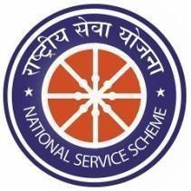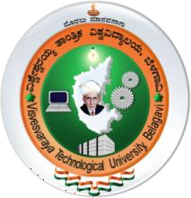

**Report on**

**Module -4**

**“Water Conservation” ”**

**Student Involved: Suprabha (1AM23CI156)**

**Under The Guidance of**

**Mrs. Vinaya S Kavalgi**

**Assistant Professor**

**Department of CSE-AIML, AMCEC**

**Description of the Activity:**

* Water conservation is the careful management and efficient use of water resources to

ensure their sustainable availability for present and future generations.

* This practice involves the responsible use of water in various sectors, such as residential,

industrial, agricultural, and environmental, to minimize waste and promote water

efficiency.

* Water conservation is essential to address the growing global water crisis, mitigate the impacts of climate change, and protect ecosystems.
* Implementing water-saving measures on individual, community, and institutional levels

contributes to the responsible and sustainable management of this precious resource.

* Preserve natural ecosystems, such as wetlands and watersheds, that play a crucial role in

maintaining water quality and availability.